SỞ GIÁO DỤC - ĐÀO TẠO TP.HCM  TRƯỜNG THPT TRƯỜNG CHINH  Đề chính thức |  | ĐỀ KIỂM TRA HỌC KỲ I  Môn: TIẾNG ANH 11 - Năm học: 2016 - 2017  Thời gian làm bài: 60 phút  (Đề thi có 03 trang)
 | Mã đề thi 146
Họ và tên thí sinh: …………………………………………………
Số báo danh: ……………………………………………………….

SECTION A: MULTIPLE CHOICE (6 points):
Mark the letter A, B, C, or D on your answer sheet to indicate the word whose underlined part differs from the other three in pronunciation in each of the following questions:
Question 1: A. compete B. contest C. question D. ethnic
Question 2: A. yellow B. under C. useful D. union
Question 3: A. home B. hour C. half D. happy
Mark the letter A, B, C, or D on your answer sheet to indicate the word that differs from the other three in the position of primary stress in each of the following questions:
Question 4: A. volunteer B. orphanage C. average D. hospital
Question 5: A. expect B. repeat C. support D. method
Mark the letter A, B, C, or D on your answer sheet to indicate the correct answer to each of the following questions:
Question 6: We have to protect our country’s natural ______________, such as coal,oil, and forests.
A. population B. rates C. resources D. methods
Question 7: In the year 2100, there will be 11 billion of us. How will the planet be able to feed all of these people?
A. report B. survive C. fight D. support
Question 8: On the days of Tet, everyone tries to be nice and polite ______________ each other.
A. to B. at C. with D. for
Question 9: On the first days of Tet, people visit relatives and friends and _______ wishes.
A. give B. exchange C. express D. say
Question 10: He later apologised ______________ his behaviour.
A. for B. on C. to D. of
Question 11: The mountain climbers are in danger of ___________ by an avalanche.
A. being dying B. killing C. being died D. being killed
Question 12: John got into trouble when he refused ___________ his briefcase for the customs officer.
A. to open B. being opened C. to be opened D. opening
Question 13: I hope __________ will be comfortable here. We try to make each guest feel at home.
A. everyone B. everything C. no one D. someone
Question 14: It’s the government’s responsibility to__________for the sick.
A. care B. treat C. cure D. guard
Question 15: A person who decides who has won a competition is called a (an) ____________.
A. referee B. investigator C. witness D. judge
Mark the letter A, B, C, or D on your answer sheet to show the underlined, part that needs correction:
Question 16: She was waiting nervous in the waiting room for the interview.
A B C D
Question 17: English –speaking contests in schools help students improving their speaking skills.
A B C D

Question 18: You can congratulate yourself about having done an excellent job.
A B C D
Question 19: British people are very interested in watching and take part in sports.
A B C D
Question 20: I asked him what kind of movies did he like and he said he liked fantasy movies.
A B C D
Read the following passage and mark the letter A, B, C, or D on your answer sheet to indicate the correct word or phrase that best fits each of the numbered blanks from 21 to 25 :
Valentine's Day is always (21) ______________ February 14th. It is not a national holiday. On weekdays, schools are open. Banks are open. People go to work. Life goes on as usual, (22) _________there is one difference. People give cards and gifts to friends and people they love.
Children also give cards to their friends at school parties. Flowers and candies are (23) _______ gifts on this day. Stores sell chocolates and other candies in (24) _________shapes. Valentine's Day was a religious holiday, but it is a day of love and (25) ______________.
Question 21: A. From B. For C. In D. On
Question 22: A. although B. and C. but D. so
Question 23: A. typical B. interesting C. ordinary D. popular
Question 24: A. rectangle B. heart C. square D. round
Question 25: A. friend B. friendly C. friendliness D. friendship
Read the following passage and mark the letter A, B, C, or D on your answer sheet to indicate the correct answer to each of the questions from 26 to 30:
If you plan your visit in October, don’t miss the Harvest Festival. The festival offers a variety of activities for all age groups and interests. Children will enjoy listening to traditional stories and learning folk dances. Adults will enjoy the antique show and the crafts fair. Other attractions include a celebration of musical heritage and demonstrations of traditional skills such as candle making, butter churning, and bee keeping. The festival is held at the County Fairgrounds, ten miles outside of town on Highway 64 West. Space is available for you to park your car at the festival at no extra charge. The admission fee of $2 for adults and $1 for children is donated to the Preserve Our History Fund.
Question 26: Which of the following activities isn’t mentioned in the notice?
A. Butter churning and bee keeping B. Dancing
C. Candle making D. Cooking
Question 27: What activity is available for children?
A. Ball playing B. Painting C. Dancing D. Singing
Question 28: How does the advertisement assume that people get to the fairgrounds?
A. Drive a car B. Walk C. Fly D. Take the subway
Question 29: Where’s the festival organized?
A. Space B. Highway 64 West
C. At the County Fairgrounds D. At Harvest Festival
Question 30: What happens to the admission fee?
A. It pays for supplies. B. It is used to rent the fairgrounds.
C. It is donated to an organisation D. It pays the performers

SECTION B: WRITING (3 points):
Use the correct forms of the words in brackets:
- Lack of water will stunt the (grow) _________ of plants.
- WHO is a(n) (nation) ______________ organisation.
- After months of working, we (final)__________finished the project ahead of the scheduled time.
- (populate) ______________ in some developing countries may be the cause of poverty and hunger.
- As your doctor, I urge you to cut down on (fat) _____________ foods if you don't want to have heart trouble.
Use the correct tense / forms of the verbs in brackets:
- I’ll go with you when I’ve finished (do)______________my homework.
- When I was a child, I usually (spend) ______________ hours playing with a tin box.
- What (you/do)______________ if you (be)______________ the principal of this school?
- They will prepare everything carefully before she ( come) ______________ back tomorrow.
- Since he left his country 6 years ago, he (return) to visit his friends several times.
Finish each of the following sentences in such a way that it means the same as the sentence printed before it:
- “Please come for a tea with me this weekend.” she said to us.
She invited _________________________________________________________________
- “It was nice of you to invite me to your birthday party. Thanks very much.”
Mike thanked me
- “I have always wanted to sail around the world.” Paul said.
Charlie has always dreamed ___________________________________________________
- I had seen the photograph of the place. I had no desire to go there. (use a Perfect participle)
__________________________________________________________________________
- “I will be surprised if Linda doesn’t pass her exam.”
Our teacher said _____________________________________________________________

SECTION C: LISTENING (1 point):
You will hear some information about a travel agency. Listen and choose the correct answer.
You will hear the conversation three times.
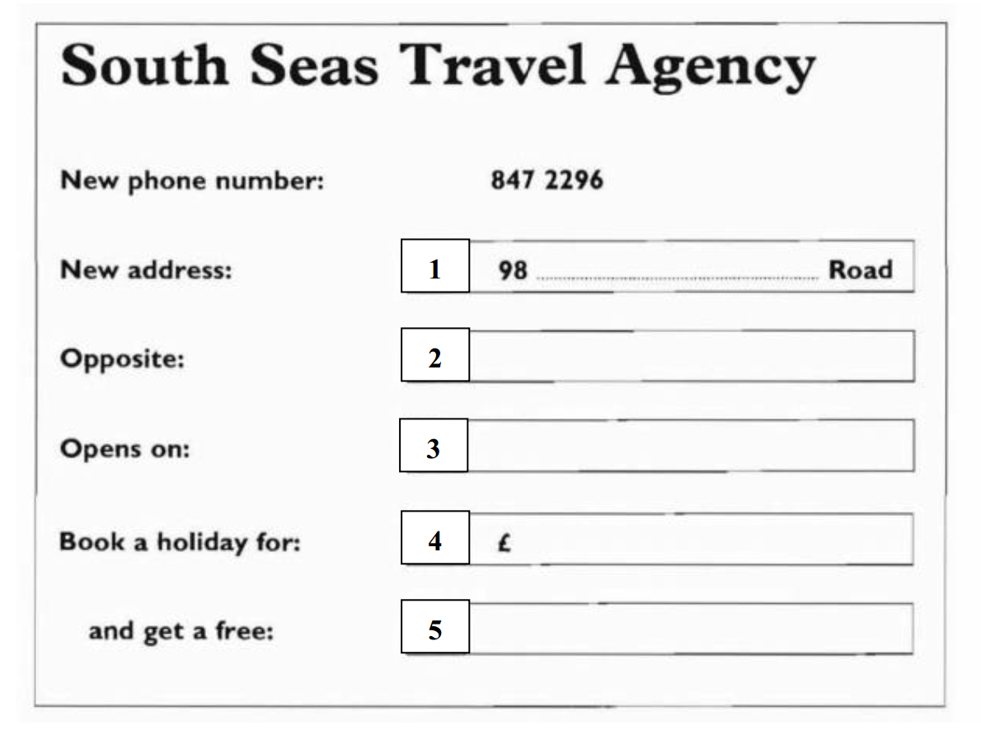

- A. Warnock B. Vornock C. Wornock
- A. park B. bank C. clock
- A. 24th May B. 26th May C. 21st May
- A. £ 315 B. £ 350 C. £ 250
- A. travel bag B. bag C. travel backpack
______________  THE END  _______________

